What's an API?

An API is a set of definitions and protocols for building and integrating application software. It’s sometimes referred to as a contract between an information provider and an information user—establishing the content required from the consumer (the call) and the content required by the producer (the response). For example, the API design for a weather service could specify that the user supplies a zip code and that the producer replies with a 2-part answer, the first being the high temperature, and the second being low.

In other words, if you want to interact with a computer or system to retrieve information or perform a function, an API helps you communicate what you want to that system so it can understand and fulfil the request.

REST is an acronym for REpresentational State Transfer and an architectural style for distributed hypermedia systems.

REST is a set of architectural constraints, not a protocol or a standard. API developers can implement REST in a variety of ways.

When a client request is made via a RESTful API, it transfers a representation of the state of the resource to the requester or endpoint. This information, or representation, is delivered in one of several formats via HTTP: JSON (Javascript Object Notation), HTML, XLT, Python, PHP, or plain text. JSON is the most generally popular file format to use because, despite its name, it’s language-agnostic, as well as readable by both humans and machines.

Example 1:

groupId: com.restApi

artifactId: FirstRestApi
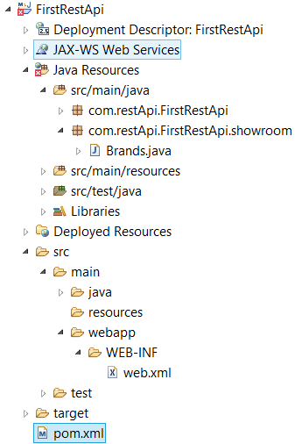

pom.xml

<build>

<finalName>FirstRestApi</finalName>

<plugins>

<plugin>

<groupId>org.apache.maven.plugins</groupId>

<artifactId>maven-compiler-plugin</artifactId>

<version>2.5.1</version>

<inherited>true</inherited>

<configuration>

<source>1.8</source>

<target>1.8</target>

</configuration>

</plugin>

</plugins>

</build>

<dependencyManagement>

<dependencies>

<dependency>

<groupId>org.glassfish.jersey</groupId>

<artifactId>jersey-bom</artifactId>

<version>${jersey.version}</version>

<type>pom</type>

<scope>import</scope>

</dependency>

</dependencies>

</dependencyManagement>

<dependencies>

<dependency>

<groupId>org.glassfish.jersey.containers</groupId>

<artifactId>jersey-container-servlet-core</artifactId>

<!-- use the following artifactId if you don't need servlet 2.x compatibility -->

<!-- artifactId>jersey-container-servlet</artifactId -->

</dependency>

<dependency>

<groupId>org.glassfish.jersey.inject</groupId>

<artifactId>jersey-hk2</artifactId>

</dependency>

<!-- uncomment this to get JSON support <dependency> <groupId>org.glassfish.jersey.media</groupId>

<artifactId>jersey-media-json-binding</artifactId> </dependency> -->

<dependency>

<groupId>javax.servlet</groupId>

<artifactId>servlet-api</artifactId>

<version>3.0-alpha-1</version>

</dependency>

<!-- https://mvnrepository.com/artifact/javax.servlet/javax.servlet-api -->

<dependency>

<groupId>javax.servlet</groupId>

<artifactId>javax.servlet-api</artifactId>

<version>4.0.1</version>

<scope>provided</scope>

</dependency>

</dependencies>

<properties>

<jersey.version>3.0.0-M6</jersey.version>

<project.build.sourceEncoding>UTF-8</project.build.sourceEncoding>

</properties>

web.xml

<?xml version="1.0" encoding="UTF-8"?>

<!-- This web.xml file is not required when using Servlet 3.0 container,

see implementation details http://jersey.java.net/nonav/documentation/latest/jax-rs.html -->

<web-app version="2.5" xmlns="http://java.sun.com/xml/ns/javaee" xmlns:xsi="http://www.w3.org/2001/XMLSchema-instance" xsi:schemaLocation="http://java.sun.com/xml/ns/javaee http://java.sun.com/xml/ns/javaee/web-app_2_5.xsd">

<servlet>

<servlet-name>Jersey Web Application</servlet-name>

<servlet-class>org.glassfish.jersey.servlet.ServletContainer</servlet-class>

<init-param>

<param-name>jersey.config.server.provider.packages</param-name>

<param-value>com.restApi.FirstRestApi</param-value>

</init-param>

<load-on-startup>1</load-on-startup>

</servlet>

<servlet-mapping>

<servlet-name>Jersey Web Application</servlet-name>

<url-pattern>/*</url-pattern>

</servlet-mapping>

</web-app>

Brands.java

package com.restApi.FirstRestApi.showroom;

import jakarta.ws.rs.GET;

import jakarta.ws.rs.Path;

import jakarta.ws.rs.Produces;

import jakarta.ws.rs.core.MediaType;

@Path("/showroom")

public class Brands {

@GET

@Path("/getBrands")

// showroom/getBrands

@Produces(MediaType.TEXT_PLAIN)

public String getBrands() {

return "List of Brands";

}

}

For testing the App: (Port number can be change):

http://localhost:8080/FirstRestApi/showroom/getBrands

